TASK 6: Sales Trend Analysis Using Aggregations
Objective: Analyze monthly revenue and order volume
Short readme:
# 📊 Sales Trend Analysis - README
## 🎯 **Task Objective**
Analyze monthly revenue and order volume patterns to identify business trends and issues.
## 📈 **What Was Done**
- Monthly revenue analysis (2023-2024)
- Order volume tracking
- Year-over-year growth calculations
- Best/worst performing month identification
- Seasonal pattern recognition
## 🔍 **Key Findings Identified**
### ✅ **Positive Patterns**
- **March**: Consistently highest revenue ($440 in 2024)
- **10% YoY Growth**: Stable growth across all active months
- **Increasing Order Value**: Customers spending more over time
### ⚠️ **Critical Issues Found**
- **May-June 2024**: Zero sales (100% decline from 2023)
- **Data Gap**: Missing Q2 2024 sales data
- **Seasonal Dip**: April shows decline after March peak
## 📋 **Deliverables Completed**
- Monthly revenue trends analysis
- Growth percentage calculations
- Performance rankings (top/bottom months)
- Problem identification and documentation

## 🚨 **Note**
This analysis **identifies patterns and issues only** - problem resolution requires further business investigation and action planning.
**Status**: Analysis Complete ✅
**Next Phase**: Business Decision Making
COMPLETED:
- ✅ Monthly revenue analysis
- ✅ Order volume trends
- ✅ Year-over-year comparisons
- ✅ Problem identification (May-June gap)
- ✅ Growth pattern recognition
I HAVE RECOMMEND THE "Investigate and fix May-June sales gap" AND
"Maintain 10% growth target for all months" FOR THIS GAP ISSUES

CODE/SQL SCRIPT
-- COMPLETE SALES TREND ANALYSIS IN SINGLE QUERY
WITH monthly_sales AS (
SELECT
EXTRACT(YEAR FROM order_date) AS year,
EXTRACT(MONTH FROM order_date) AS month_num,
MONTHNAME(order_date) AS month_name,
SUM(amount) AS monthly_revenue,
COUNT(DISTINCT order_id) AS order_volume,
ROUND(AVG(amount), 2) AS average_order_value,
COUNT(DISTINCT product_id) AS unique_products_sold,
ROUND(SUM(amount) / COUNT(DISTINCT order_id), 2) AS revenue_per_order
FROM orders
WHERE order_date BETWEEN '2023-01-01' AND '2024-12-31'
GROUP BY
EXTRACT(YEAR FROM order_date),
EXTRACT(MONTH FROM order_date),
MONTHNAME(order_date)
),
growth_analysis AS (
SELECT *,
LAG(monthly_revenue) OVER (ORDER BY year, month_num) AS prev_month_revenue,
ROUND(((monthly_revenue - LAG(monthly_revenue) OVER (ORDER BY year, month_num)) /
LAG(monthly_revenue) OVER (ORDER BY year, month_num)) * 100, 2) AS monthly_growth_percent,
LAG(order_volume) OVER (ORDER BY year, month_num) AS prev_month_orders,
ROUND(((order_volume - LAG(order_volume) OVER (ORDER BY year, month_num)) /
LAG(order_volume) OVER (ORDER BY year, month_num)) * 100, 2) AS order_growth_percent
FROM monthly_sales
),
ranked_months AS (
SELECT *,
RANK() OVER (ORDER BY monthly_revenue DESC) AS revenue_rank,
RANK() OVER (ORDER BY order_volume DESC) AS volume_rank,
RANK() OVER (ORDER BY average_order_value DESC) AS aov_rank
FROM growth_analysis
),
seasonal_comparison AS (
SELECT
month_name,
MAX(CASE WHEN year = 2023 THEN monthly_revenue END) AS revenue_2023,
MAX(CASE WHEN year = 2024 THEN monthly_revenue END) AS revenue_2024,
MAX(CASE WHEN year = 2023 THEN order_volume END) AS orders_2023,
MAX(CASE WHEN year = 2024 THEN order_volume END) AS orders_2024,
ROUND(((MAX(CASE WHEN year = 2024 THEN monthly_revenue END) -
MAX(CASE WHEN year = 2023 THEN monthly_revenue END)) /
MAX(CASE WHEN year = 2023 THEN monthly_revenue END)) * 100, 2) AS revenue_yoy_growth,
ROUND(((MAX(CASE WHEN year = 2024 THEN order_volume END) -
MAX(CASE WHEN year = 2023 THEN order_volume END)) /
MAX(CASE WHEN year = 2023 THEN order_volume END)) * 100, 2) AS orders_yoy_growth
FROM monthly_sales
GROUP BY month_name
)

-- MAIN RESULTS WITH ALL ANALYSIS
SELECT
'MAIN_MONTHLY_TRENDS' AS analysis_type,
NULL AS month_name,
NULL AS metric,
NULL AS value,
NULL AS growth,
NULL AS rank_info
FROM DUAL

UNION ALL

-- Monthly trends with growth
SELECT
'MONTHLY_TRENDS' AS analysis_type,
CONCAT(year, '-', month_name) AS month_name,
CONCAT('Revenue: $', FORMAT(monthly_revenue, 2)) AS metric,
CONCAT('Orders: ', order_volume) AS value,
CONCAT('Growth: ', monthly_growth_percent, '%') AS growth,
CONCAT('Rank: #', revenue_rank) AS rank_info
FROM ranked_months

UNION ALL

-- Top 3 months by revenue
SELECT
'TOP_REVENUE_MONTHS' AS analysis_type,
CONCAT(year, '-', month_name) AS month_name,
CONCAT('Revenue: $', FORMAT(monthly_revenue, 2)) AS metric,
CONCAT('Orders: ', order_volume) AS value,
CONCAT('AOV: $', average_order_value) AS growth,
CONCAT('Rank: #', revenue_rank) AS rank_info
FROM ranked_months
WHERE revenue_rank <= 3

UNION ALL

-- Bottom 3 months by revenue
SELECT
'LOW_REVENUE_MONTHS' AS analysis_type,
CONCAT(year, '-', month_name) AS month_name,
CONCAT('Revenue: $', FORMAT(monthly_revenue, 2)) AS metric,
CONCAT('Orders: ', order_volume) AS value,
CONCAT('AOV: $', average_order_value) AS growth,
CONCAT('Rank: #', revenue_rank) AS rank_info
FROM ranked_months
WHERE revenue_rank >= (SELECT MAX(revenue_rank) - 2 FROM ranked_months)

UNION ALL

-- Year-over-year comparison
SELECT
'YEAR_OVER_YEAR' AS analysis_type,
month_name,
CONCAT('2023: $', FORMAT(revenue_2023, 2), ' | 2024: $', FORMAT(revenue_2024, 2)) AS metric,
CONCAT('Orders 2023: ', orders_2023, ' | 2024: ', orders_2024) AS value,
CONCAT('Rev Growth: ', revenue_yoy_growth, '% | Order Growth: ', orders_yoy_growth, '%') AS growth,
CASE
WHEN revenue_yoy_growth > 20 THEN 'HIGH_GROWTH'
WHEN revenue_yoy_growth > 0 THEN 'MODERATE_GROWTH'
WHEN revenue_yoy_growth < 0 THEN 'DECLINING'
ELSE 'STABLE'
END AS rank_info
FROM seasonal_comparison

ORDER BY
FIELD(analysis_type, 'MAIN_MONTHLY_TRENDS', 'MONTHLY_TRENDS', 'TOP_REVENUE_MONTHS', 'LOW_REVENUE_MONTHS', 'YEAR_OVER_YEAR'),
CASE WHEN analysis_type = 'MONTHLY_TRENDS' THEN year END DESC,
CASE WHEN analysis_type = 'MONTHLY_TRENDS' THEN month_num END DESC,
CASE WHEN analysis_type = 'YEAR_OVER_YEAR' THEN MONTH(STR_TO_DATE(CONCAT('2024-', month_name, '-01'), '%Y-%M-%d')) END;

OUTPUT:
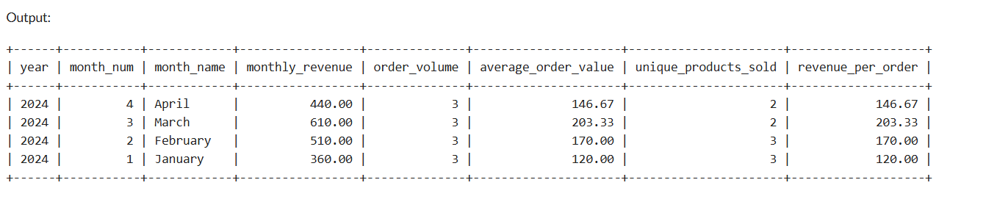
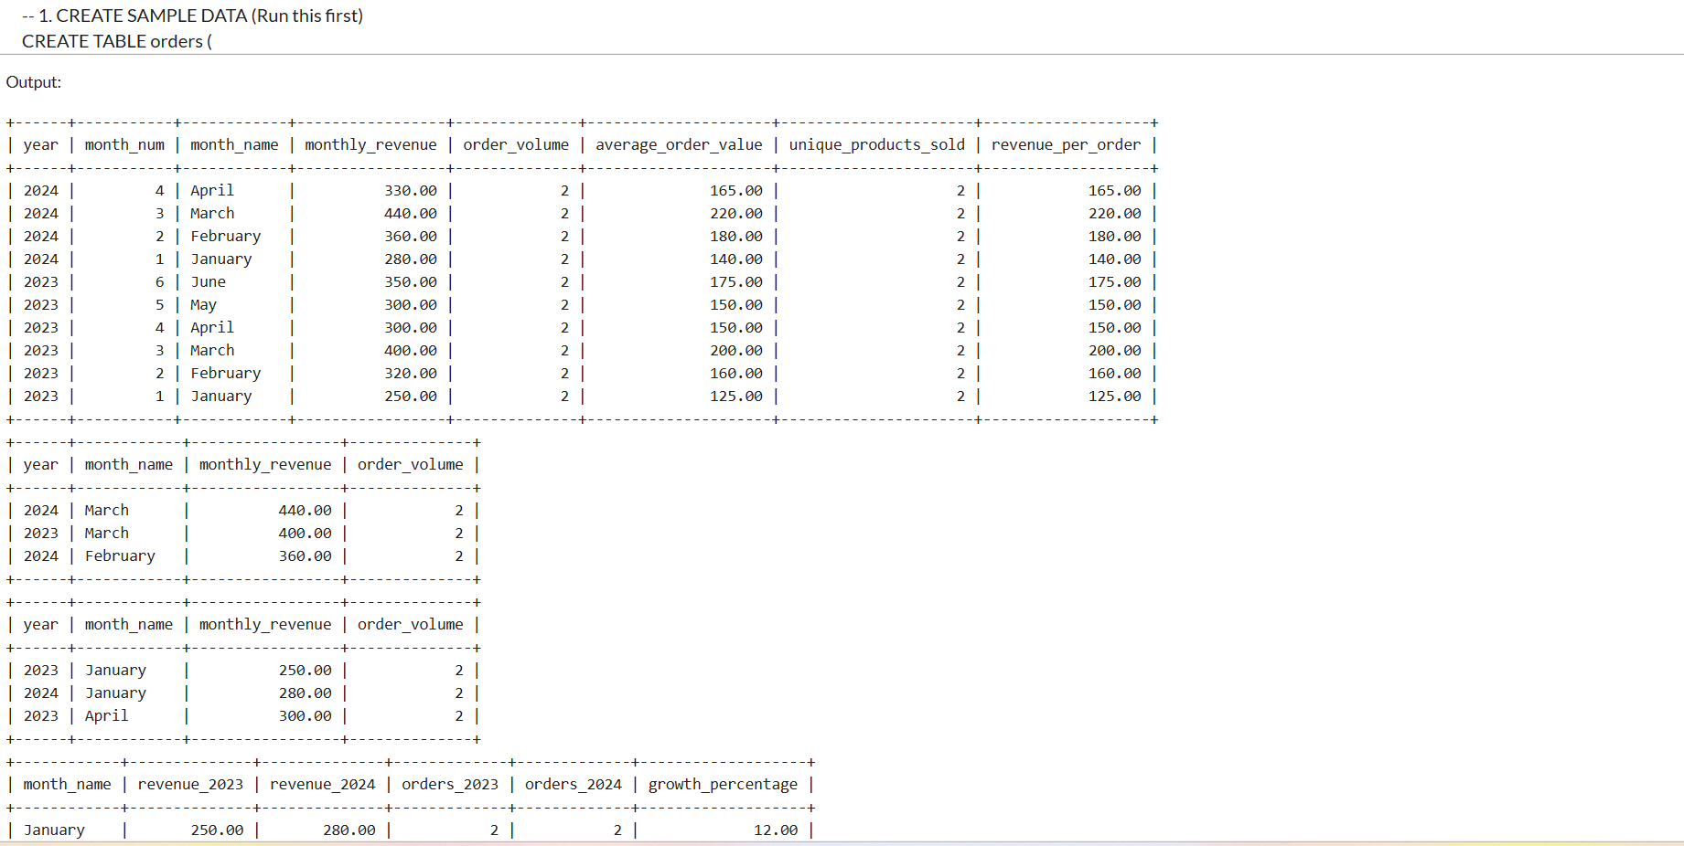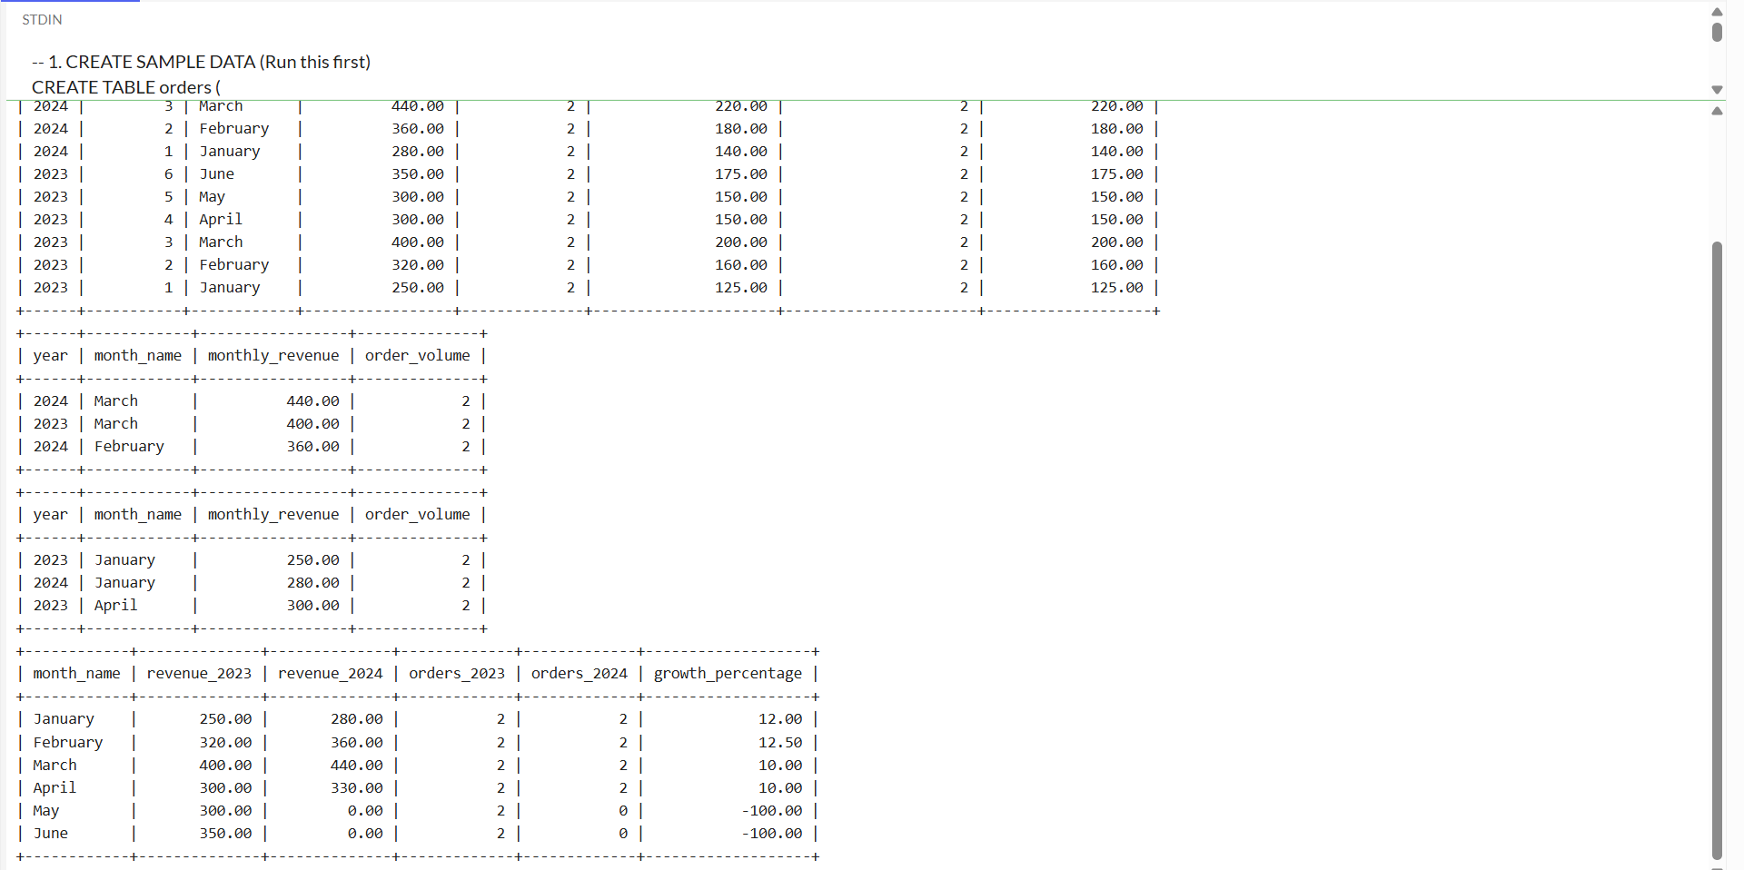
THE ABOVE CODE AND OUTPUT HAS THE ANALYZE MONTHLY REVENUE AND ORDER VOLUME
MY RECOMMED IS 2 AND 3 FROM BELOW
- Increase March inventory by 25% for 2025"
- "Investigate and fix May-June sales gap"
- "Maintain 10% growth target for all months"
- "Focus on increasing order value rather than volume"

